Background
You will be using Playwright to login to https://www.saucedemo.com with different users that represent different scenarios to test
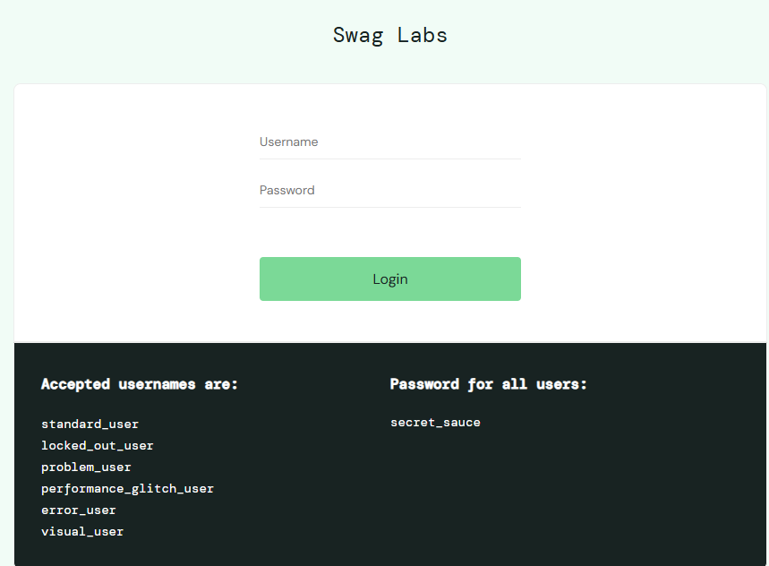

Scenarios

Happy Path
- Login with standard_user
- Add 3 items to the cart
- Remove 1 of the 3 items
- Click Shopping Cart icon
- On resulting page, click Checkout
- On resulting page, Enter First Name, Last Name and Zip/Postal Code and click Continue
- On resulting page,
  - Find the element below and change whatever price you have to Total: $500
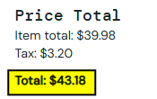
  - Click Finish
- On resulting page, click Back Home

Failed Login
- Attempt to login with standard_user locked_out_user
- Verify you see a login message like below and report it
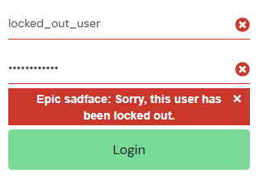

Problem User
- Login with problem_user
- 2 items will be in cart when logged in and they are only 2 items the site will allow you to have in cart as this user
- Try to Add items to cart
  - Report any issues
- Try to Remove items from cart
  - Report any issues
- Click Shopping Cart icon
- On resulting page, click Checkout
- On resulting page, Enter First Name, Last Name and Zip/Postal Code and click Continue
  - Report any issues on this page preventing you from clicking Continue button
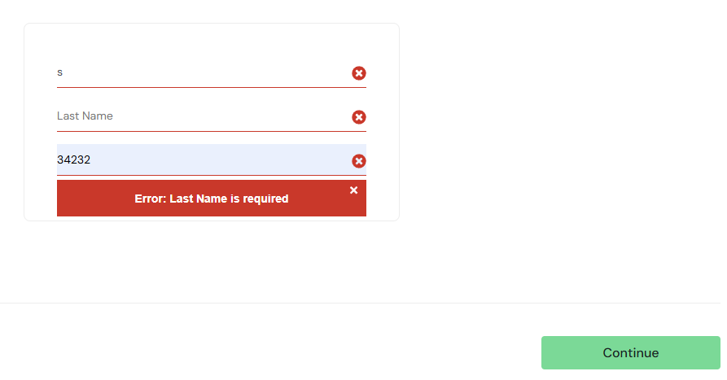

Glitchy User
- Login with performance_glitch_user
This user does random stuff. Try to follow the Scenario 2.1 (Happy Path) steps exactly and if something doesn’t work like it should abort test and report the issue

Error User
- Login with error_user
- Add 3 items to the cart
- Remove 1 of the 3 items
- Click Shopping Cart icon
- On resulting page, click Checkout
- On resulting page, Enter First Name, Last Name and Zip/Postal Code and click Continue
  - It won’t let you enter Last Name
- On resulting page, click Finish
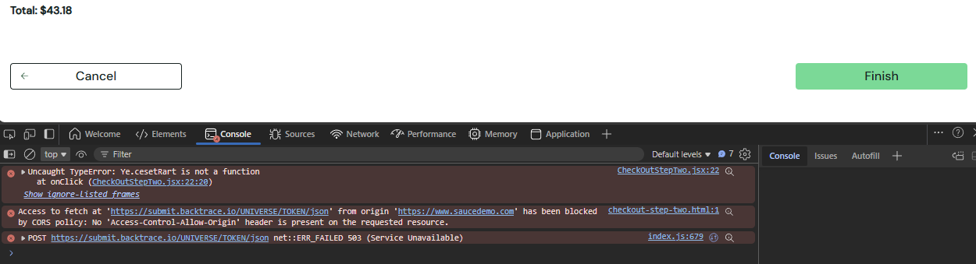
Errors prevent Finish button from working Report the Errors

Detect Visual Error
- Login with visual_user
https://www.saucedemo.com/inventory.html
- Report any UI elements that are outside their “boxes” when compared to the standard_user
  - There should be at least 2 on the page

Expectations
- Each scenario requires a Playwright test to run
- We want to see you play each scenario with Playwright live to us
  - AFTER the above scenarios, we'll ask you to make an adjustment to test and watch you perform it live
- What functionality does Playwright provide as far as reporting the output of each run
  - Please provide some type of report of each scenario as part of the execution
- Use Page Object Model (POM) for scripts
  - Be able to explain the scripts and selectors used
- BONUS 1: Are you able to make one test that is parameterized?
  - Taking the Scenario 1: Happy Path test as the standard and then passing the username/password for other tests into it and be able to abort if necessary if something in UI is blocking the test from continuing?
- BONUS 2: Can you have Playwright run the tests in Chrome and Edge or Firefox?
- BONUS 3: Can you have Playwright run the tests simulating iPhone or Android?
- BONUS 4: Can you have Playwright or something else do some simple Performance or Load testing of 10 users?
- BONUS 5: If you have access to any environment where you can demonstrate or explain a CI/CD gated check-in (for example, where a build and automated UI tests must pass before a merge or check-in is allowed), we would love to see or discuss it.
We understand you may not have access to Azure DevOps, GitHub, or a personal project where this is currently configured, so this can be shown either through a live example, screenshots, configuration files, or a walkthrough explanation.

